A Rule-Based Hydro–Solar–Wind–Battery Renewable Dispatch Simulation with SCADA-Inspired Analytics for a Jabalpur Case Study
Oihika Arpit
Independent Renewable Energy Systems Portfolio Project | Electronics and Communication Engineering Background | India
ABSTRACT
This report presents a Python-based offline minimum viable product (MVP) for a Hydro–PV–Wind–Battery Energy Management System (EMS), developed as an extension of the author's earlier Hydro–Solar–Battery simulation. The revised model explicitly integrates a 40 MW illustrative wind resource with a 55 MW solar PV resource, a 34.10 MW hydropower reference ceiling, and a 70 MWh battery with a 17.5 MW power limit. A 24-hour synthetic demand profile is supplied through rule-based dispatch, while SCADA-inspired operational indicators, residual-load trajectories, Duck Curve metrics, reserve margin, frequency, voltage, and carbon emissions are recorded. In the executed run, total demand was 2625.00 MWh and renewable generation supplied 1311.97 MWh, giving a renewable supply share of 49.98%. Wind contributed 138.60 MWh, corresponding to 5.28% of daily demand and 10.56% of the renewable energy dispatched. The average modeled wind capacity factor was 14.44%. The report distinguishes the canonical solar-only Duck Curve from the variable-renewable residual load, Net Load = Demand − Solar − Wind. The solar-only evening reference ramp was 13.35 MW, while the solar-plus-wind evening ramp was 14.20 MW. After the simulated hydro/BESS control sequence, the reported peak evening ramp was 15.23 MW. Thus, this particular run did not demonstrate positive Duck Curve mitigation; the negative result is retained as an engineering finding rather than being adjusted. The work is a transparent educational and portfolio-level simulation, not a real-time SCADA controller or certified grid study.
Index Terms—Hydropower; Solar PV; Wind energy; Battery energy storage; Energy management system; Duck Curve; Residual load; SCADA-inspired analytics; Grid stability; Jabalpur; Python simulation
REPORT ORGANIZATION
Section | Content
I | Introduction and project evolution
II | System architecture, wind integration and input parameters
III | Mathematical model and control logic
IV | Duck Curve and wind relationship
V | SCADA-inspired grid stability analytics
VI | Python implementation and reproducibility
VII | Results and engineering discussion
VIII | Figures and output interpretation
IX | Limitations, future work and conclusion

I. INTRODUCTION
A. Motivation
Hybrid renewable systems must coordinate resources with different temporal and operational characteristics. Solar PV is strongly diurnal, wind generation is variable and may complement or reinforce solar ramps, hydropower can provide dispatchable balancing within an availability ceiling, and BESS can provide fast short-duration flexibility. A useful EMS therefore needs to represent not only energy production, but also the interactions among resource variability, storage state, residual load, and system reserve.
B. Project Evolution
The original project model was a Hydro–Solar–Battery MVP. The present report extends that model by adding an explicit wind generation block and by propagating wind through the complete analytical chain: wind speed → available wind power → dispatch → renewable supply → residual load → Duck Curve/ramp metrics → BESS and hydro requirements → reserve margin → simplified frequency/voltage indicators → carbon accounting. This creates a single-source technical narrative for the project.
C. Case-Study Context and Scope
The hydropower reference is inspired by the author's vocational exposure to the Rani Avanti Bai Hydel Power Station in the Jabalpur region. The simulation does not use confidential plant operating data. Hydro operating values are treated as reference parameters, while the hourly demand, solar profile, and wind-speed profile are synthetic modelling inputs. Consequently, the numerical results describe the behaviour of the implemented model, not measured plant performance.

II. SYSTEM ARCHITECTURE AND INPUT DATA
A. Integrated Resource Set
The system contains four energy resources/storage elements: solar PV, wind, hydropower, and BESS, plus fossil/grid fallback. Solar and wind are treated as variable renewable resources. Hydro is represented as dispatchable renewable generation subject to hourly availability. BESS is modelled through SOC, charge and discharge limits, and round-trip efficiency.
B. Wind Integration
Wind capacity is fixed at 40 MW. Hourly wind speed is converted into available wind power through a simplified turbine curve with cut-in, rated, and cut-out regions. The resulting available power is dispatched directly when demand exists. This wind signal is then included in the variable-renewable residual-load equation. Therefore, wind affects both the energy balance and the shape of the residual-load curve rather than appearing only as an isolated generation plot.
C. Main Parameters
The principal parameters used by the executed model are listed in Table I. They are intentionally kept visible so the numerical results can be reproduced and interpreted without assuming undocumented plant data.
Parameter | Value | Role in model
Solar capacity | 55 MW | Variable renewable generation
Wind capacity | 40 MW | Variable renewable generation
Hydro reference ceiling | 34.10 MW | Dispatchable renewable balancing
Battery power limit | 17.50 MW | Charge/discharge limit
Battery energy capacity | 70.00 MWh | SOC state variable
Initial SOC | 68% | Initial stored-energy condition
Minimum SOC | 20% | Lower operating bound
Maximum SOC | 95% | Upper operating bound
Nominal frequency | 50 Hz | Simplified stability reference
Nominal voltage | 1.00 pu | Simplified stability reference
Rolling stability window | 3 h | Windowed indicator classification

III. MATHEMATICAL MODEL AND CONTROL LOGIC
A. Solar PV Model
P_PV,t = P_PV,max × s_t, where P_PV,max = 55 MW and s_t is the deterministic hourly solar profile. The profile is zero during night hours and reaches its maximum around midday.
B. Wind Model
Wind availability is derived from hourly wind speed. For the simplified turbine representation, power is zero below cut-in speed, increases approximately with v³ below rated speed, remains at rated power between rated and cut-out limits, and becomes zero above cut-out speed. The implemented capacity is 40 MW.
C. Canonical Residual-Load Relations
The solar-only Duck Curve reference is NL_solar,t = D_t − P_PV,t. After wind integration, the variable-renewable residual load becomes NL_VRE,t = D_t − P_PV,t − P_W,t. This distinction is important: the canonical solar-only curve is retained as the baseline, while the solar-plus-wind curve shows how wind changes the system residual-load trajectory.
D. Battery State of Charge
For a one-hour interval, the model updates stored energy using charging and discharging efficiencies. A generic form is E_(t+1) = E_t + η_c P_c,t Δt − P_d,t Δt / η_d, subject to minimum and maximum SOC and the battery power limit.
E. Flexibility and Ramp Relations
After variable renewable generation, hydro and BESS can reduce the remaining residual load. The hourly ramp is calculated as ΔNL_t = NL_t − NL_(t−1). The evening-window peak ramp is used to evaluate whether flexibility actually mitigates the Duck Curve in the executed run.
Input / stage | Primary relation | Downstream outputs
Solar PV | Demand − Solar | Solar-only net load, Duck Curve depth, ramp
Wind | Wind speed → available MW | Wind dispatch, VRE residual load, ramp
Solar + Wind | Demand − Solar − Wind | Canonical VRE residual load
BESS | SOC + charge/discharge limits | Residual load after storage, final SOC
Hydro | Availability-constrained dispatch | Residual load after hydro, reserve
Fossil/grid | Unmet residual demand | Carbon emissions, fallback energy
Dispatch + reserve | Mismatch + available flexibility | Frequency/voltage indicators

IV. RULE-BASED ENERGY DISPATCH
A. Rule-Based Sequence
At each hour, the controller first serves demand from solar and wind generation. Any surplus variable renewable energy may charge the BESS within its operating limits. If a deficit remains, BESS discharge is considered, followed by hydro dispatch. Any remaining unmet demand is supplied by fossil/grid fallback. The sequence is deterministic and transparent rather than optimization-based.
B. Why Wind Changes the Dispatch
Wind changes the amount of demand served before storage and hydro are called. When wind generation is available, the residual load is lower; when wind falls, the residual load can rise even if solar generation is changing smoothly. This means wind can reduce energy demand on hydro/BESS while simultaneously changing the timing and magnitude of the ramp that those flexibility resources must manage.
Step | Decision | Effect of wind
1 | Serve load from solar and wind | Wind directly lowers residual demand when available.
2 | Charge BESS from eligible surplus | Wind can create additional charging opportunity when combined with solar.
3 | Discharge BESS for deficit | Wind reduces the deficit that storage must cover.
4 | Dispatch hydro within availability | Wind changes the residual demand presented to hydro.
5 | Use fossil/grid fallback | Wind reduces fallback only when its energy displaces unmet demand.

V. DUCK CURVE ANALYSIS AND WIND RELATIONSHIP
A. Solar-Only Reference
The model reports a solar-only Duck Curve depth of 60.00 MW. This metric represents the separation between the gross demand trajectory and the solar-driven midday residual-load depression used as the baseline in the code.
B. Wind Relationship
Wind contributed 138.60 MWh over the 24-hour simulation. Its average capacity factor was 14.44%. The peak evening ramp increased from 13.35 MW for the solar-only reference to 14.20 MW after wind was included. This is a direct illustration of why wind should not automatically be described as Duck Curve mitigation: its effect depends on its temporal profile.
C. Hydro and BESS Relationship
In the executed run, the final peak evening ramp after the implemented hydro/BESS logic was 15.23 MW. The resulting reported ramp mitigation was -34.18%, i.e., negative. Midday BESS charging was 0.00 MWh and evening BESS discharge was 0.00 MWh. The controller therefore did not reserve sufficient BESS energy for the defined evening window in this run. This is retained as a control-design finding.
Metric | Executed result | Interpretation
Duck Curve depth | 60.00 MW | Solar-driven midday residual-load depression.
Peak evening ramp, solar-only | 13.35 MW | Reference evening ramp.
Peak evening ramp, solar + wind | 14.20 MW | Wind-integrated residual-load ramp.
Peak evening ramp, hydro | 15.23 MW | Residual after hydro in the modeled control sequence.
Peak evening ramp, BESS | 15.23 MW | Final reported ramp after the implemented flexibility sequence.
Ramp mitigation | -34.18% | Negative result: no mitigation in this run.
Midday BESS charging | 0.00 MWh | No charging recorded in the defined midday window.
Evening BESS discharge | 0.00 MWh | No evening discharge recorded.

VI. SCADA-INSPIRED GRID STABILITY ANALYTICS
A. Frequency Indicator
The model uses a simplified frequency indicator around a 50 Hz nominal value. The executed run produced an average of 49.996 Hz, with a range of 49.950–50.049 Hz. This is an analytical indicator generated by the simulation equations, not a swing-equation, governor, or electromagnetic-transient study.
B. Voltage Indicator
The modeled voltage indicator averaged 1.0059 pu, with a range of 1.0000–1.0100 pu. The indicator is linked to dispatch mismatch and reserve in the code and should not be interpreted as a load-flow result.
C. Reserve and Rolling Window
The minimum reserve margin reached 0.00%. The instantaneous classifier recorded 19 stable hours, 5 warning hours, and 0 stress hours. The three-hour rolling stability window was classified as stable for 17 hours. Wind contributes to these indicators indirectly because changes in wind generation change residual demand and therefore the dispatch requirement and available reserve.
Indicator | Result
Average frequency | 49.996 Hz
Frequency range | 49.950–50.049 Hz
Average voltage | 1.0059 pu
Voltage range | 1.0000–1.0100 pu
Minimum reserve margin | 0.00%
Instantaneously stable hours | 19
Warning hours | 5
Stress hours | 0
Stable 3-hour-window hours | 17

VII. PYTHON IMPLEMENTATION AND REPRODUCIBILITY
A. Implementation Structure
The implementation is organized around deterministic input profiles, source-availability functions, BESS SOC tracking, hourly dispatch, metric calculation, and output generation.
B. Output Data Structure
The executed CSV contains 45 output fields covering demand, solar, wind, hydro, BESS, fossil support, reserve, ramp, frequency, voltage, carbon emissions, Duck Curve residual-load stages, and rolling stability indicators.
C. Reproducibility
The report uses the saved CSV, system assumptions JSON, metrics JSON and corresponding PNG figures from the same executed run.
Wind output | Direct relation to system
Wind speed (m/s) | Determines available wind power through the simplified turbine curve.
Wind available (MW) | Upper bound on wind dispatch.
Wind dispatch (MW) | Reduces demand that must be served by BESS, hydro or fossil/grid.
Wind capacity factor (%) | Normalizes average wind output against 40 MW nameplate capacity.
Solar + wind residual load | Defines the variable-renewable residual-load trajectory.
Wind ramp contribution | Changes hourly residual-load ramp and evening ramp metrics.
Reserve margin | Changes residual demand and therefore the available flexibility requirement.
Frequency/voltage indicators | Wind-induced mismatch changes feed the simplified stability equations.
Carbon emissions | Wind energy displaces fossil/grid support when dispatched.

VIII. RESULTS AND ENGINEERING DISCUSSION
A. Energy Balance
Total daily demand was 2625.00 MWh. Solar supplied 501.05 MWh, wind supplied 138.60 MWh, hydro supplied 640.40 MWh, and BESS discharge supplied 31.92 MWh. The renewable-energy total reported by the code was 1311.97 MWh, equivalent to 49.98% of demand. Fossil/grid support was 1313.03 MWh.
B. Wind Contribution
Wind provided 5.28% of daily demand and 10.56% of the renewable energy dispatched. Because the wind profile is relatively modest compared with the 40 MW nameplate capacity, the modeled average capacity factor was 14.44%. Wind was fully dispatched in the executed run, with essentially zero modeled curtailment.
C. Battery Behaviour
The final BESS SOC was 20.00%. The run recorded 0.00 MWh of charging and 31.92 MWh of discharge. The lack of evening discharge is significant for Duck Curve mitigation: the model could not demonstrate a storage-supported reduction in the evening ramp under the current dispatch sequence.
D. Carbon Accounting
The simulation reported total carbon emissions of 1076687.30 kg CO2e. Emissions are associated with fossil/grid fallback under the illustrative carbon factor specified in the model. Wind reduces fossil requirement when it is available, so its contribution to the carbon result is represented through the energy balance.
Indicator | Result
Daily electrical demand | 2625.00 MWh
Solar energy dispatched | 501.05 MWh
Wind energy dispatched | 138.60 MWh
Hydro energy dispatched | 640.40 MWh
BESS discharge | 31.92 MWh
Renewable energy supplied | 1311.97 MWh
Renewable supply share | 49.98%
Fossil/grid support | 1313.03 MWh
Average wind capacity factor | 14.44%
Final BESS SOC | 20.00%
Total carbon emission | 1076687.30 kg CO2e

IX. GENERATED OUTPUT FIGURES
Each figure is placed separately so that axes, legends and captions remain readable. These figures are the direct PNG outputs of the executed simulation.
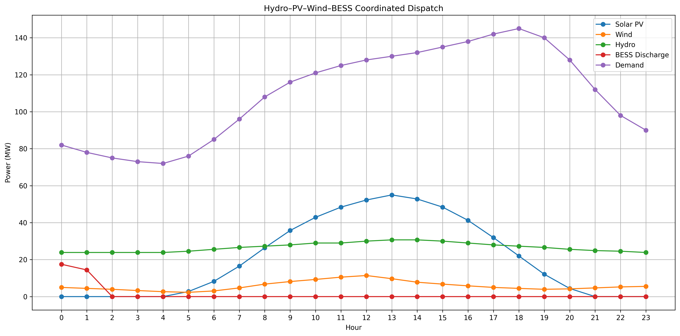
Fig. 1. Four-source dispatch showing the interaction of solar PV, wind, hydropower, BESS and residual supply.
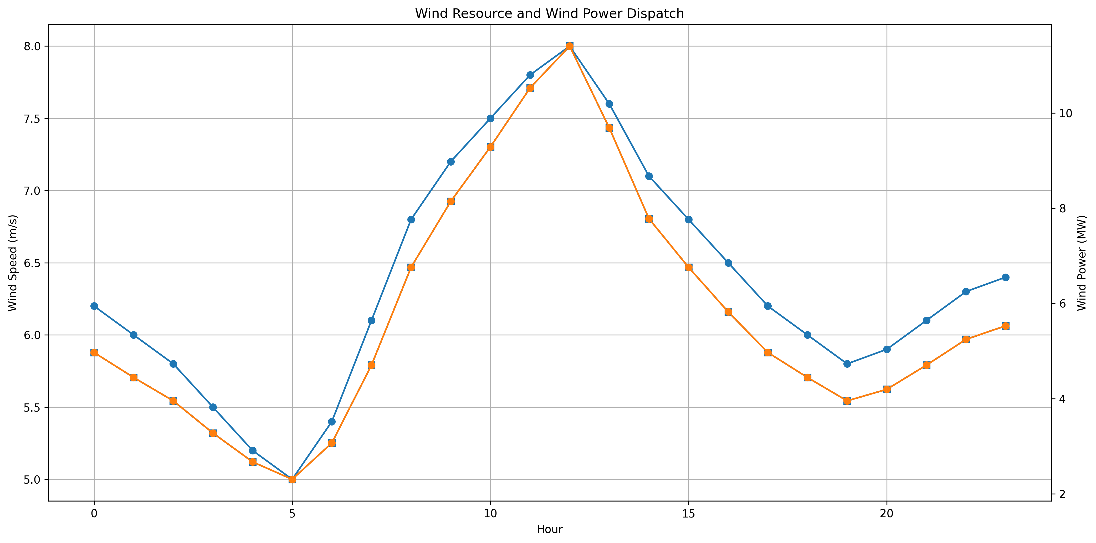
Fig. 2. Wind resource and dispatch relationship; wind availability is derived from the modeled wind-speed profile.

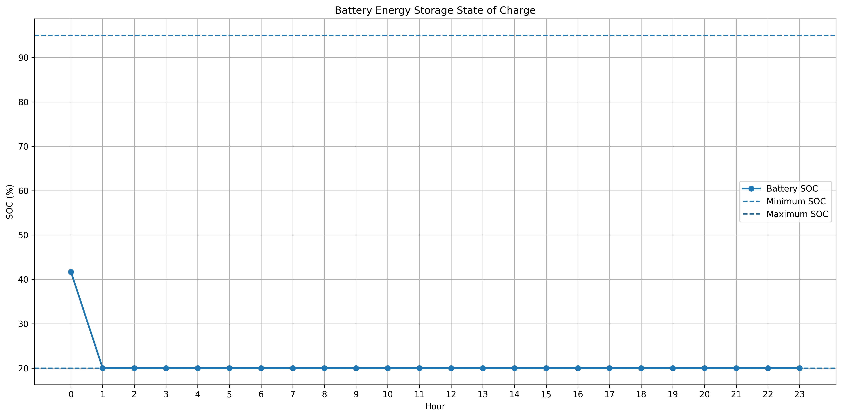
Fig. 3. Battery SOC trajectory under the implemented charging/discharging rules.
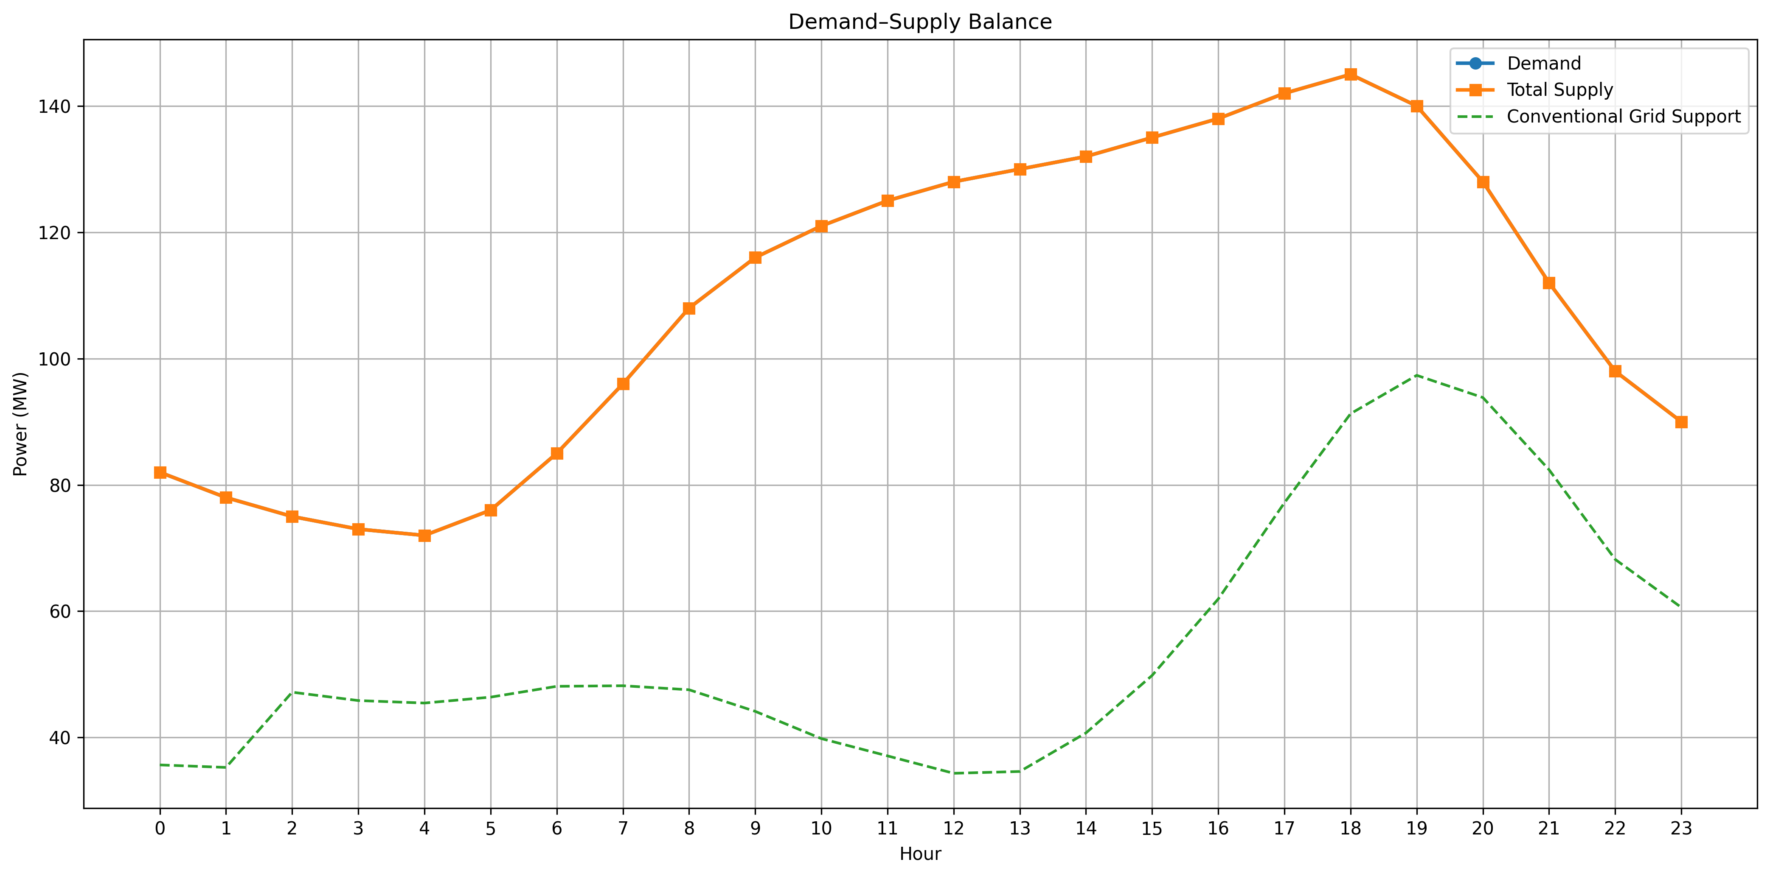
Fig. 4. Hourly demand and total supply balance.

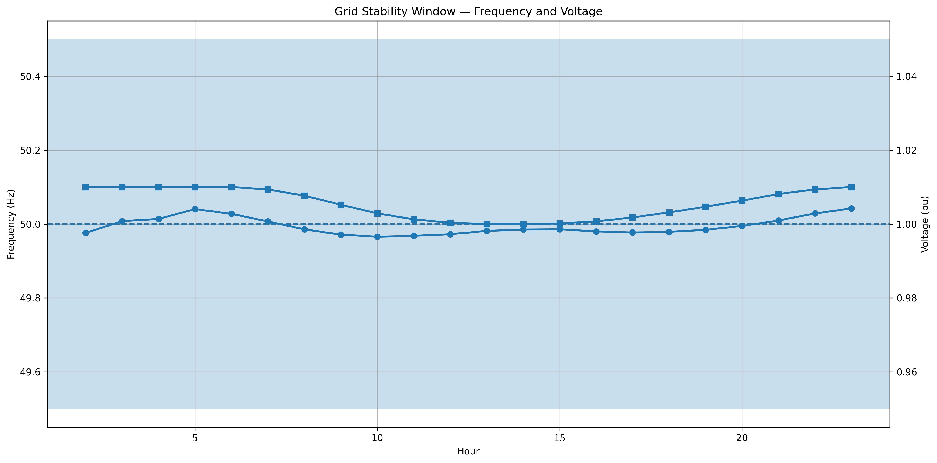
Fig. 5. Instantaneous and rolling grid-stability indicators generated by the model.
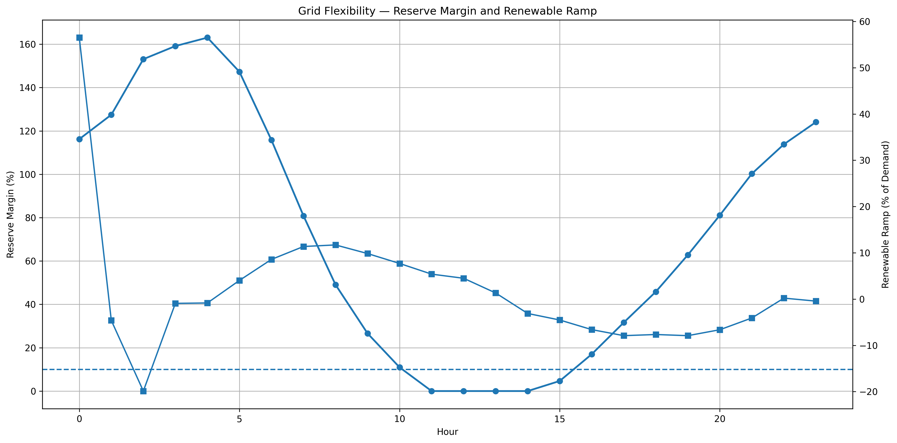
Fig. 6. Reserve margin and renewable-ramp behaviour; wind affects the residual renewable trajectory.

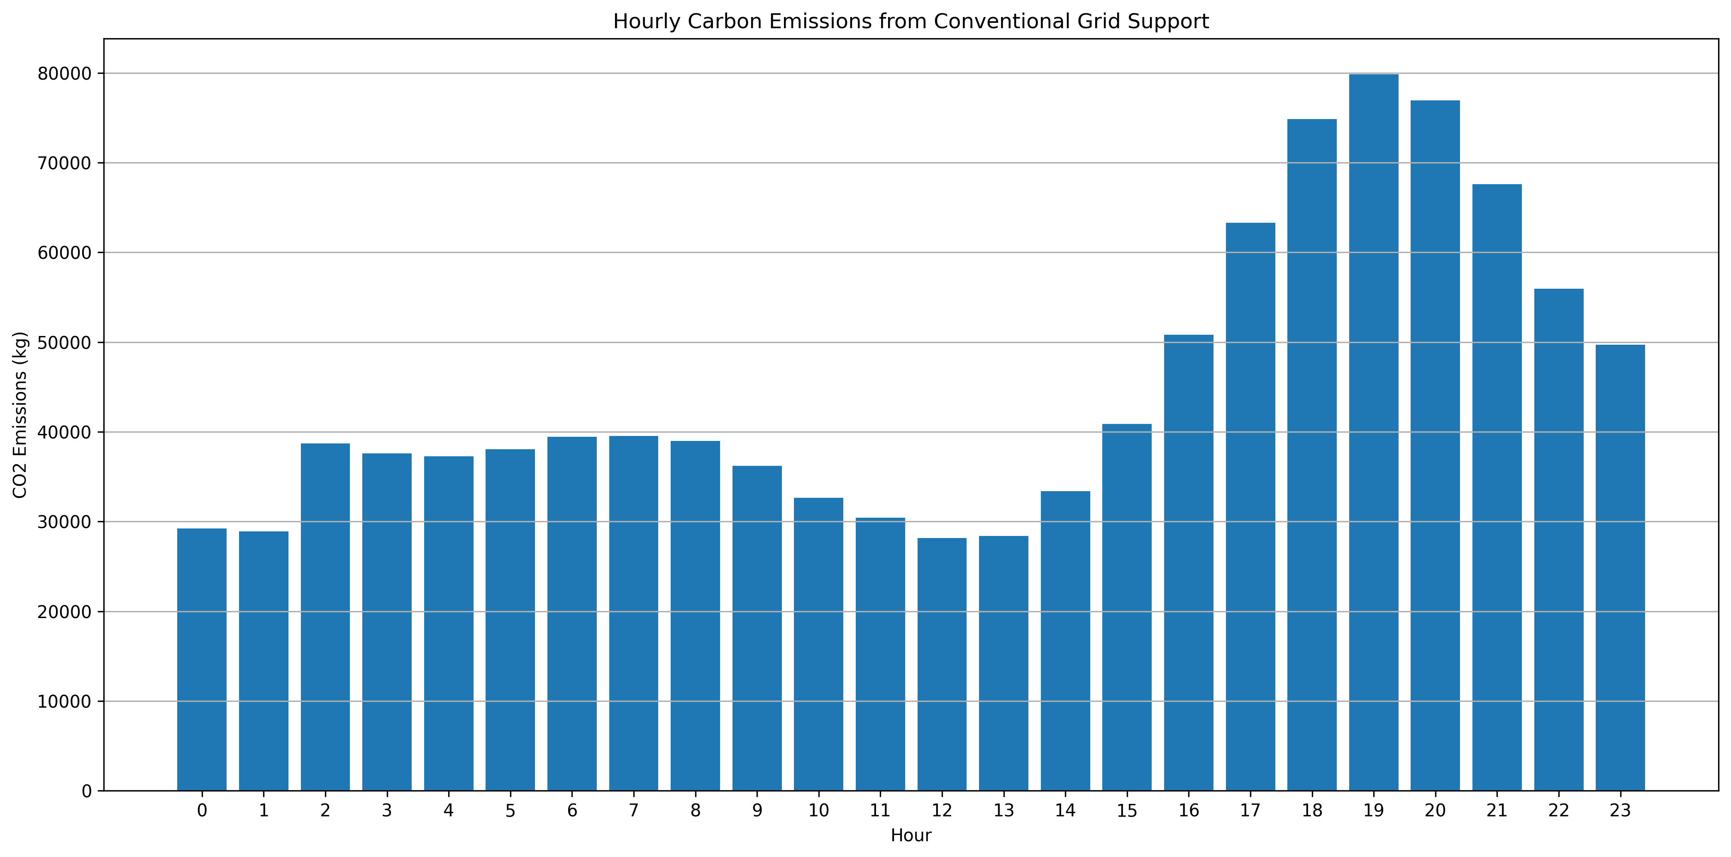
Fig. 7. Hourly carbon-emission contribution associated with fossil/grid fallback.
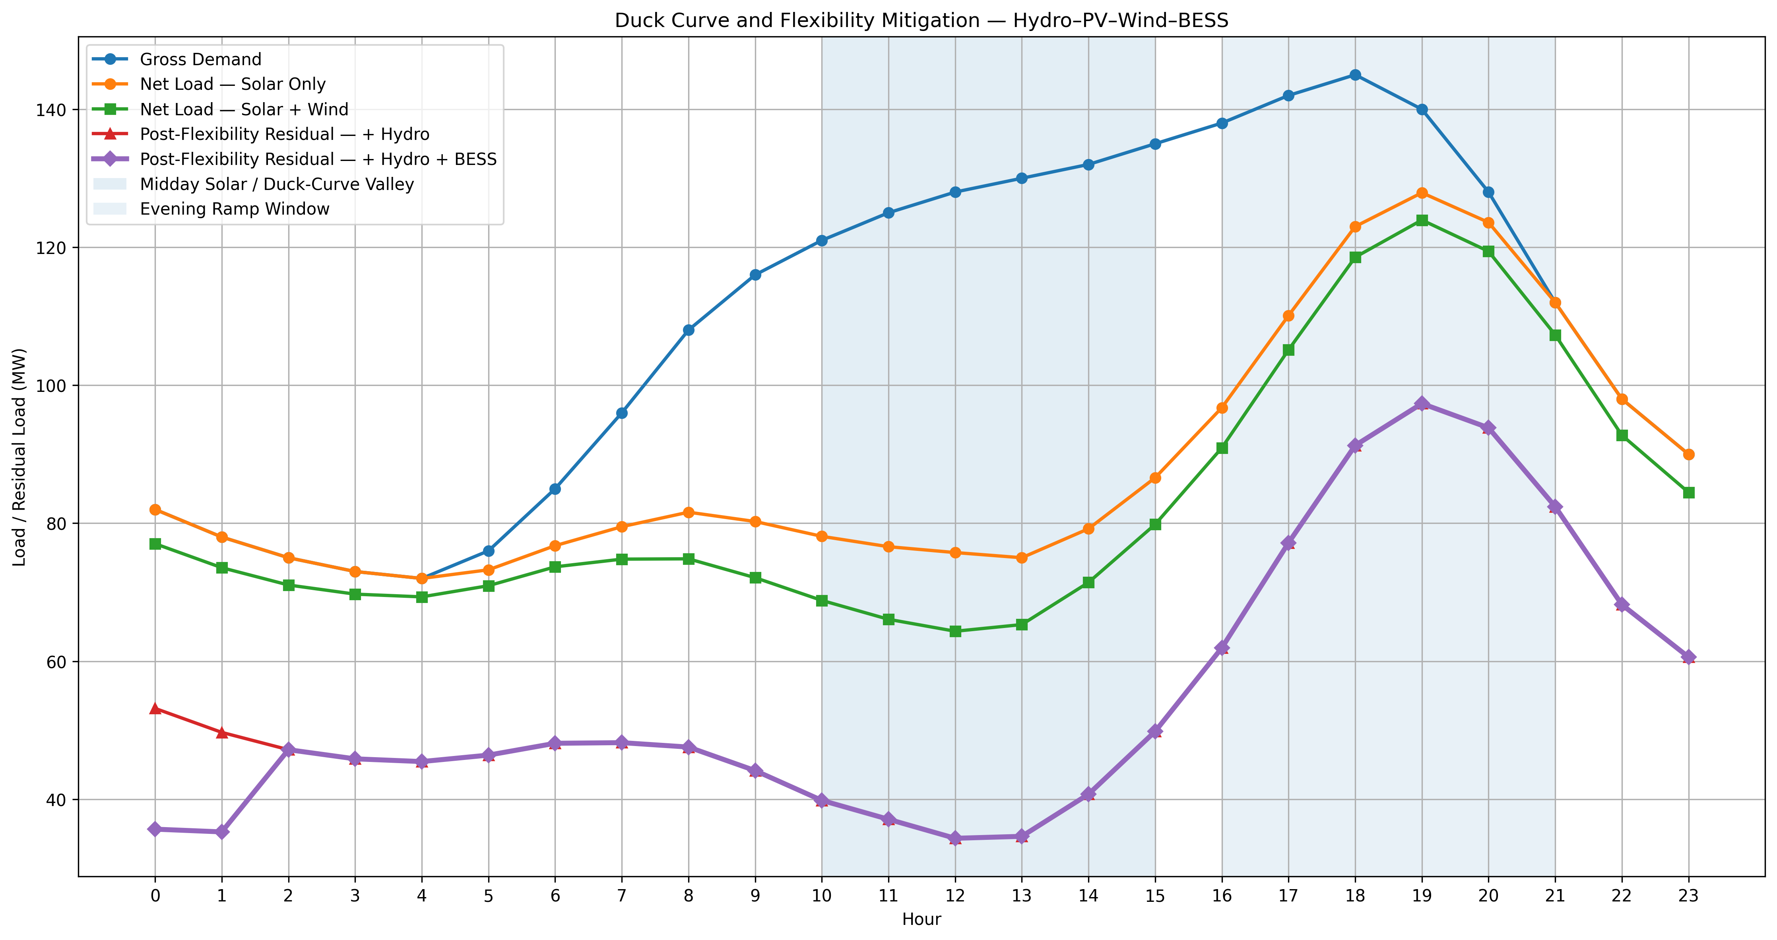Fig. 8. Duck Curve and residual-load comparison across the solar, wind and flexibility stages.

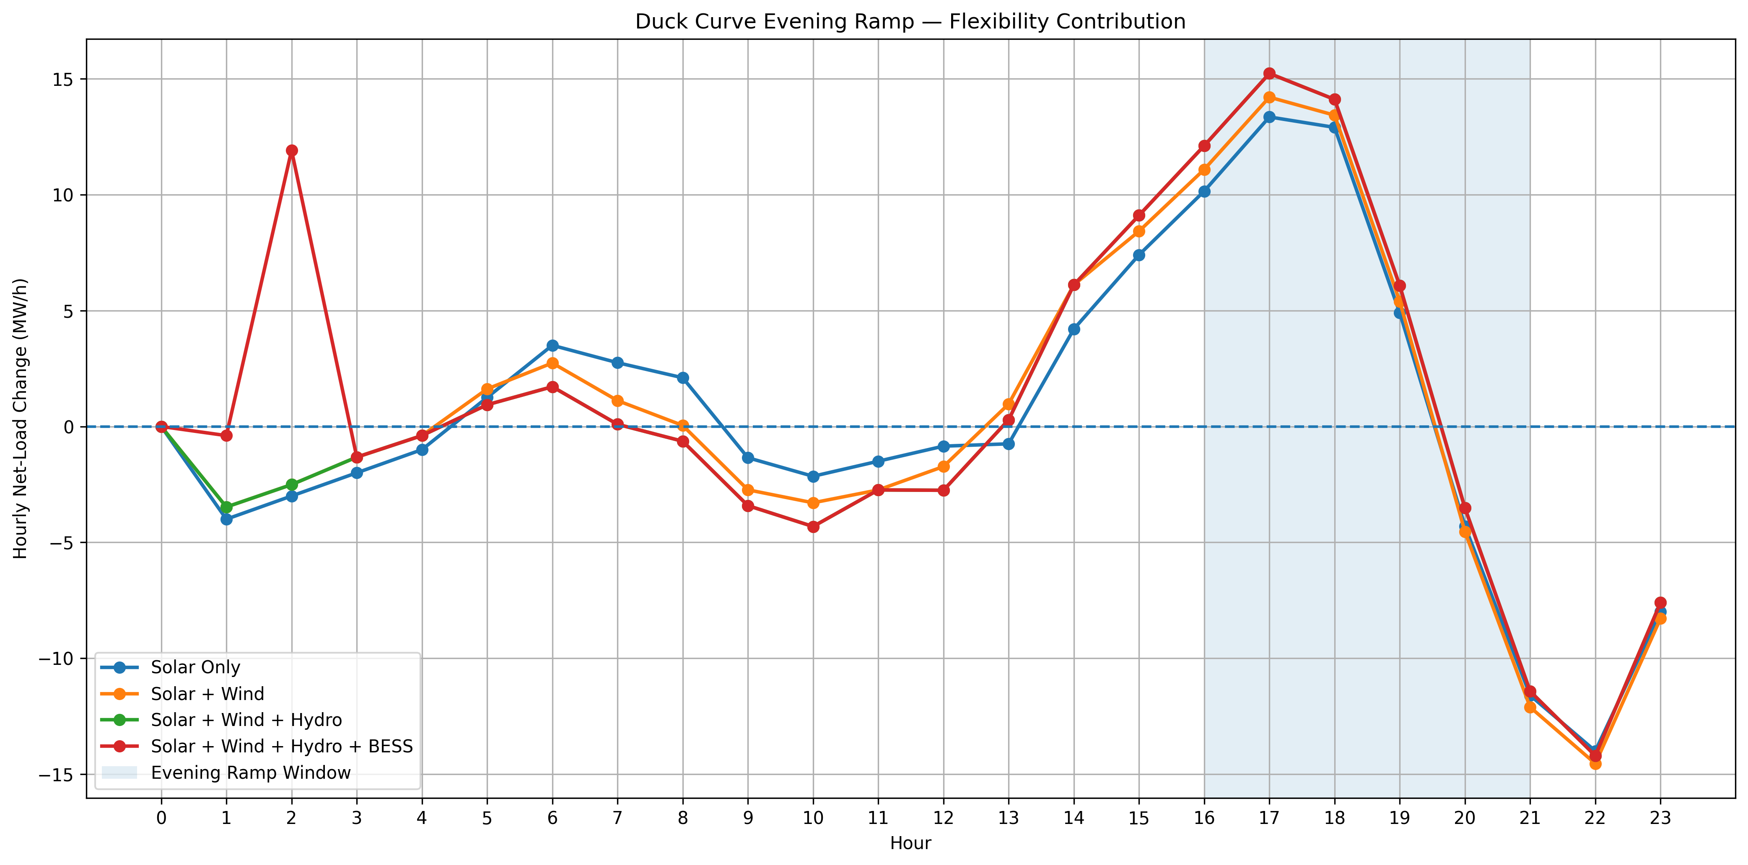
Fig. 9. Evening ramp comparison: solar-only, wind-integrated, hydro-supported and BESS-supported trajectories.
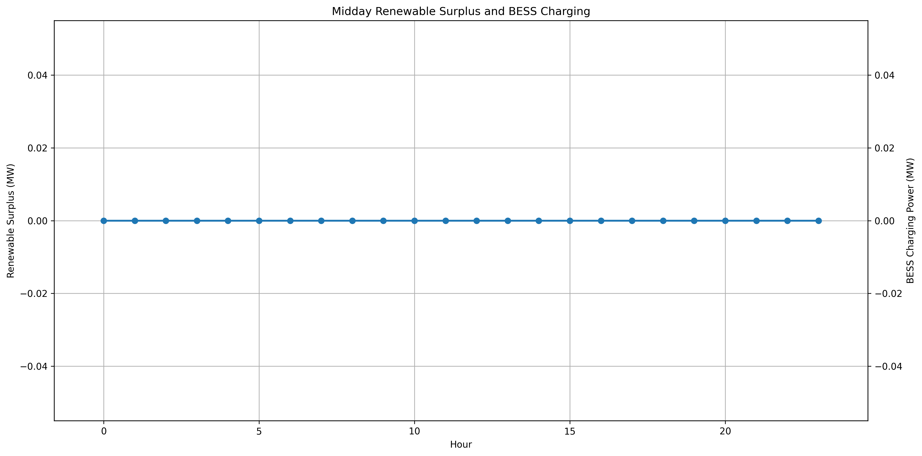Fig. 10. Midday renewable surplus and BESS charging; the executed run recorded no midday charging.

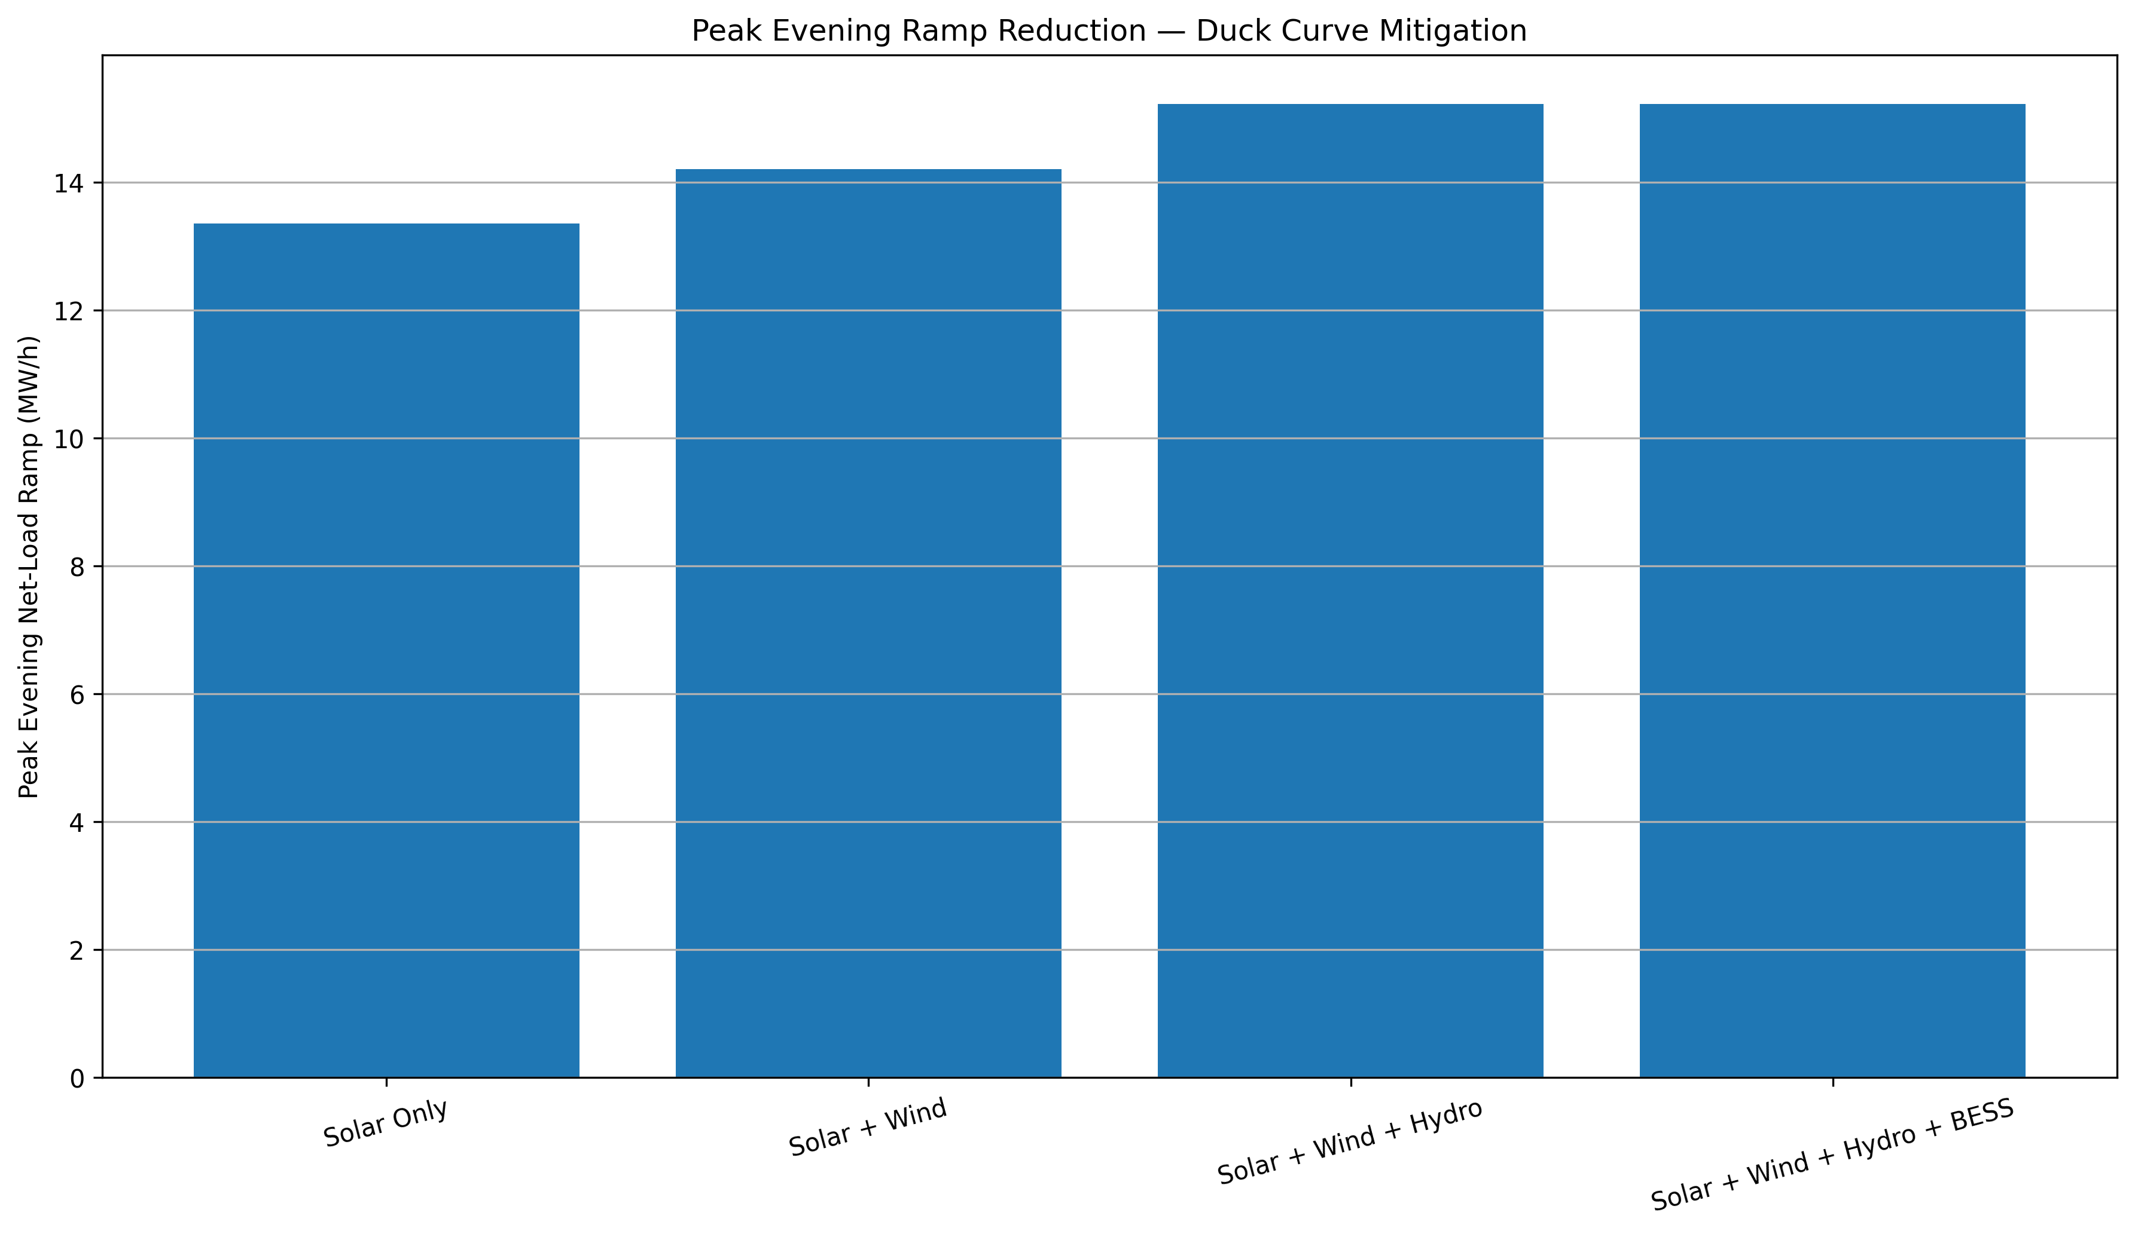
Fig. 11. Peak evening ramp comparison and the resulting control-performance metric.
X. LIMITATIONS AND FUTURE WORK
A. Synthetic Inputs
Demand, solar availability, and wind-speed profiles are synthetic/illustrative. They are suitable for algorithm development and portfolio demonstration but are not a substitute for measured Jabalpur time series.
B. Simplified Wind Representation
The wind model uses a simplified power curve and does not include turbulence, wake effects, air-density correction, turbine availability, forecast error, or farm-level spatial diversity.
C. Simplified Grid Indicators
Frequency and voltage are calculated using simplified indicator equations. The model does not solve generator swing equations, governor/exciter dynamics, short-circuit behaviour, unbalanced distribution power flow, or electromagnetic transients.
D. Control Result
The executed control logic did not reserve BESS energy for the evening ramp. Therefore the negative Duck Curve mitigation result should be interpreted as evidence that the rule set requires improvement, not as evidence that the physical hybrid system cannot mitigate the Duck Curve.
E. Recommended Next Control Revision
The next version should preserve an explicit evening SOC reserve, coordinate hydro with the 16:00–21:00 ramp, and evaluate the resulting residual-load trajectory against both the solar-only and solar-plus-wind baselines.

XI. CONCLUSION
The project establishes a clean, reproducible Hydro–PV–Wind–BESS simulation in which wind is integrated throughout the energy-management and analytical chain rather than being added only as a visual generation source. The executed run supplied 49.98% of daily demand from modeled renewable resources, with wind contributing 138.60 MWh. The analysis also demonstrates an important engineering point: adding wind does not guarantee Duck Curve mitigation. In this synthetic case, the wind profile increased the peak evening ramp relative to the solar-only reference, while the current BESS dispatch did not provide evening discharge. The resulting negative ramp-mitigation metric is therefore retained as a valid control-design finding. The next technical step is to redesign the EMS so that hydro and BESS are explicitly coordinated around the 16:00–21:00 ramp, while preserving a minimum SOC reserve and evaluating the solar-plus-wind residual load. The resulting framework provides a sound foundation for later validation using measured renewable profiles and higher-fidelity grid models.
REFERENCES
- Casazola-Cruz, O., Pilco-Nuñez, A., & Arroyo-Paz, A. (2025). Machine learning for photovoltaic power forecasting integrated with energy storage systems: A scientometric analysis, systematic review, and meta-analysis. *Energies, 18*(23), 6291. https://doi.org/10.3390/en18236291
- Central Electricity Authority. (2024). *Final report on resource adequacy plan for the state of Madhya Pradesh (2024–25 to 2034–35).* Ministry of Power, Government of India.
- Grimaldi, A., Minuto, F. D., Brouwer, J., & Lanzini, A. (2024). Optimal energy management of a utility-scale battery energy storage system integrated with a photovoltaic power plant considering battery degradation. In *2024 IEEE Power & Energy Society General Meeting (PESGM)*. https://doi.org/10.1109/PESGM51994.2024.10761082
- Gupta, M., Arya, A., Varshney, U., Mittal, J., & Tomar, A. (2025). A review of PV power forecasting using machine learning techniques. *Power & Energy Systems*, 100058. https://doi.org/10.1016/j.pes.2025.100058
- International Telecommunication Union. (2022). *ITU-T Recommendation Y.4903 (03/2022): Key performance indicators for smart sustainable cities to assess the achievement of sustainable development goals.*
- International Telecommunication Union. (2026a). *ITU-T Recommendation Y.4242 (05/2026): Requirements and capability framework of an energy storage service for residential community in the smart city.*
- International Telecommunication Union. (2026b). *ITU-T Recommendation Y.4614 (05/2026): Energy data model for a city-level energy management platform.*
- Pengtem, C., Deeum, S., Amirullah, Ohgaki, H., Romphochai, S., Bhumkittipich, P., & Bhumkittipich, K. (2025). Design of multi-objective energy management for remote communities connected with an optimal hybrid integrated photovoltaic–hydropower–battery energy storage system (PV-HP-BESS) using improved particle swarm optimization. *Energies, 18*(9), 2250. https://doi.org/10.3390/en18092250
- Phillips, T., Lopez, C. J., Kwon, J., Mahalik, M., Durvasulu, V., & Balliet, W. H. (2026). Improving the realism of hydropower and hydropower–battery hybrid plant optimization: A forecast-aware rolling horizon model. *Renewable Energy, 273*, 126109. https://doi.org/10.1016/j.renene.2026.126109
- Tang, W., Huang, Y., Qian, T., Wei, C., & Wu, J. (2025). Coordinated central-local control strategy for voltage management in PV-integrated distribution networks considering energy storage degradation. *Applied Energy, 389*, 125684. https://doi.org/10.1016/j.apenergy.2025.125684
- Zambrano, H. H. N., Benigni, A., Lazzari, R., & Piegari, L. (2025). A forecast-driven energy management methodology for microgrids under seasonal variability. In *2025 International Conference on Clean Electrical Power (ICCEP).*

